**Today at NDOG Kidz Klub**!



**Kidz Klub**

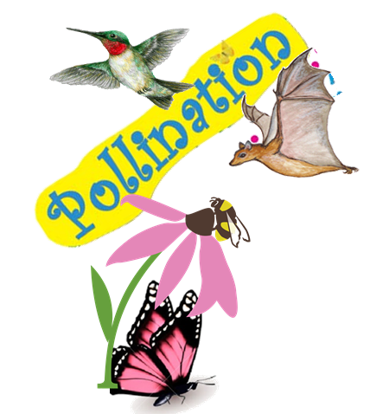



**Pollinators**

**Everywhere!**

**Today the kids will learn about bees, butterflies, moths, bats and hummingbirds**

**Each week, 8am – 9:30am, May 12 – August 11, NDOG volunteers will provide fun crafts and learning activities to children ages 3 – 10. Visit the garden during market hours for more information or contact Sherry Wenta at (870) 845-0134.**



